“FRANK BILLINGS KELLOGG”

BY

JAMES GRAFTON ROGERS
__________

FOREWORD

BY

DOUGLAS A. HEDIN
EDITOR, MLHP

Frank Billings Kellogg is remembered today as Secretary of State in the Coolidge Administration and recipient of the Nobel Peace Prize for 1929. But before gaining fame as a diplomat and, earlier, as a United States senator, he practiced law, first in Rochester and later in St. Paul. During most of the first two decades of the last century, he was the most famous member of the most prominent law firm in Minnesota: Davis, Kellogg and Severance.

Kellogg was the 35th President of the American Bar Association, serving in 1912-1913. Because of this, he came to be the subject of a chapter in James Grafton Rogers’s American Bar Leaders: Biographies of the Presidents of the American bar Association, 1878-1928, which commemorated the ABA’s Semi-Centennial. The book is comprised of sketches of three to five pages in length of the first fifty presidents.

Rogers divided the ABA’s first fifty years into five periods. Leaders during the initial period—the “founding era—which ran from the beginning of the organization in 1878 to 1893, were mostly Civil War veterans. The leaders of the “nationalization” period, from 1893 to 1904, were celebrated advocates. During the first two periods, the membership of the ABA was small but growing. It increased rapidly during the third period, from 1904 to 1913, when the association met in Montreal, its “first venture on foreign soil.” During this period the “business lawyer and the public service man” became the “predominant type.” The fourth era, from 1913 to 1924, “when a significant London trip took place, saw the full fruition” of the ABA into its ideal form. The fifth period began in 1924 and was continuing when Rogers wrote his book.

Kellogg’s presidency concluded the third period. He was, to use Rogers’s term, a “business lawyer” who carried a heavy load of trial work (always, it seems, with his partner, Cordenio A. Severance). Kellogg was enormously successful, and Rogers could not resist repeating the “open secret” that Kellogg personally paid for his “expedition” to London to encourage Lord Chancellor Haldane to attend the joint convention of the Canadian bar Association and the ABA in Montreal in 1913.
When his book came out in 1932, Rogers was serving as an assistant to Secretary of State Henry L. Stimson. Stimson valued both Rogers’s presence and his advice. As he wrote in his memoirs:

A second major new assistant was James Grafton Rogers, appointed in February [1931] to fill a position long vacant as Assistant Secretary of State. Rogers was a westerner, the only one who ever served on any of Stimson’s admin-istrative staffs. His origin was a political advantage, but it was for himself that Stimson valued him. He had great energy and ability, and his gusty wit was a major source of relief from the dismal burden of State Department duties. Rogers became Stimson’s constant adviser, at first largely on legal questions and later on matters of major policy.

From his position within the state department, Rogers hesitated to grade Kellogg on his work as Secretary of State: “The American press has quarreled over Kellogg, and it is, of course, still too soon for any final balance sheet.” Kellogg died on December 21, 1937.

Rogers died on April 24, 1971. His obituary in the New York Times the next day emphasized his government service:

James G. Rogers Dead at 88;
Ex-Assistant Secretary of State

DENVER, April 24—James Grafton Rogers, an Assistant Secretary of State under President Herbert Hoover who had also been an educator, a poet, a lawyer and a leading citizen of Colorado, died yesterday of a stroke. He was 86 years old.

Surviving are two sons, Ranger and Hamilton; a daughter, Mrs. S. H. Hart; a brother, Edmund, former superintendent of Yellowstone Park; 12 grand-children, and two great-grand-children.

A memorial service will be held Sunday at 1:30 P. M. in St. John’s Episcopal Cathedral.
_______

Presidential Liaison

Mr. Rogers served in the State Department from 1931 to 1933. He handled for Secretary Henry L. Stimson negotiations with Canada for a treaty to develop the St. Lawrence Seaway.

He acted as liaison between the Hoover and Roosevelt Administrations, staying on in Washington a year into President Franklin D. Roosevelt’s term to advise him on the critical economic situation.

He was born in Denver Jan. 13, 1883, and graduated from Yale in 1905 and Denver University Law School in 1908. He was a reporter on The New York Sun in 1905-06.
Mr. Rogers served as assistant attorney general of Colorado in 1909-10 and practiced law in Denver until 1928.

He was Dean of Denver University’s Law School in 1927, dean of law at the University of Colorado form 1928 to 1935, and master of Timothy Dwight College and professor of law at Yale from 1935 to 1942.

He served as lieutenant in the Army in World War I. During World War II he was deputy director of the Office of Strategic Services and chairman of the Strategic Planning Group.

Mr. Rogers was a member, with the rank of minister, of the Allied Electoral Mission to Greece in 1946 and a member of the foreign affairs section of the Hoover Commission on Organization of the Executive Branch of the Government in 1948.

1n the nineteen-fifties he was president and chairman of the Foreign Bondholders Protective Council, which rehabili-tated more than $1 billion worth of defaulted foreign-government bonds. Mr. Rogers, with Kenneth M. Spang, negotiated a settlement of the German debt in London in 1952.

In Colorado he served as mayor of Georgetown in the nineteen-fifties. He was a founder and former president the Civic League of Denver. He had also served as president of the Denver Council of Boy Scouts and Colorado Bar Association.

He was a founder and first president of the Colorado Mountain Club and a former president of the City, University and Cactus Clubs of Denver.

A former president and chairman of the Colorado Historical Society, Mr. Rogers made a hobby of the history of the West. He was also a naturalist and one-time president of the American Alpine Club.
In his youth he wrote books of verse and later he wrote volumes on legal themes. He also wrote the songs “Dolores” and “Santa Fe Trail.”

Throughout his legal writing and speeches, he stressed the need for improving the standards of the legal profession.

One way to improve the standards of the profession, Rogers believed, was to study the lives of the first fifty leaders of the ABA. As he wrote in his “Foreword” to the book:

Again, to a purely professional eye, this group of men should, if fairly and justly depicted, have much significance. Here ought to be some inkling of the kind of training and origin that have promoted distinction in a technical profession, of the kind of method and approach that have marked the lawyer’s mind, indeed, a glimpse of the construction and design of success upon a lawyer’s part in the eyes of his brothers of the craft. Here is the pattern of the American lawyer, with its breadth and narrowness, its strength and weakness.

The following article appeared first in James Grafton Rogers’s American Bar Leaders: Biographies of the Presidents of the American bar Association, 1878-1928 170-175 (Chicago: American Bar Association, 1932). Though reformatted, it is complete. Page breaks have been added. It is posted on the MLHP with the permission of the heirs of James Grafton Rogers.

Roger’s profile of Kellogg may be read together with his study of Cordenio A. Severance, which is posted separately on the MLHP, and Roger G. Kennedy, “Frank Billings Kellogg” (MLHP, 2008-2011). □

“FRANK BILLINGS KELLOGG”

IN

AMERICAN BAR LEADERS

BIOGRAPHIES OF THE PRESIDENTS
OF THE

AMERICAN BAR ASSOCIATION
1878 —1928

BY

JAMES GRAFTON ROGERS

PUBLISHED IN COMMEMORATION OF ITS SEMI-CENTENNIAL

BY THE AMERICAN BAR ASSOCIATION

CHICAGO
1932

FRANK BILLINGS KELLOGG *

1856 Born, Potsdam, New 1904 Began prosecution of
York. Paper Trust for U. S.
1865 Moved with parents to 1904, Delegate to Repub-
farm near Rochester, ‘08,’12 lican National Con-
Minnesota. vention; Minnesota
1865-75 Farm boy at country Committeman.
school. 1906 Began Union-Pacific-
1875-77 Studied law in Rochester, Southern Pacific Dis-
office. solution steps.
1877 Admitted, Minnesota bar. 1912-13 President, American
1879-87 Practicing at Rochester; Bar Association.
City, the County At- 1917-23 United States Senator
Torney. from Minnesota.
1887 Married Clare M. Cook 1924 Ambassador to Great
of Rochester. Britain
1887 Moved to St. Paul, join- 1925-29 Secretary of State
ing firm of Senator C. 1929 Awarded Nobel Peace
K. Davis. Prize
1887-1916 Practicing in St. Paul. 1930 Judge of World Court.
.
_______________

THE befuddled effort of the American people to arrive at some sensible treatment of its giant national railroad a business organizations has made opportunity for many political and legal careers. Bryan, McKinley, Roosevelt, Wilson and Taft, among American statesmen, were all affected by struggle. Among those who appeared chiefly as lawyers, the lives of Henry L. Stimson, Herbert Hadley, Philander C. Knox, James A. Beck, and above all, Frank B. Kellogg, were deeply influenced. The crest of public enthusiasm over the baiting of what is called “the system,” “the octopus,” “the trusts,” ‘special privilege,” “the malefactors of great wealth,” and “high finance,” and the noon hours of the group of “trust-buster” fell chiefly in the two administrations of President Roosevelt. Within a year after catastrophe had carried Roosevelt from a supposedly retired shelf into the Presidency, he struck, _______________

* © James Grafton Rogers. This article is posted with the permission of the heirs of James Grafton Rogers.
to quote himself, his “own note” and “started the trust control campaign.” In later years, he interpreted the sequence of stirring litigation which followed as an assertion of national power and capacity to control business as it deemed necessary, rather than as any real solution of the problem. [171]

Since 1870, the States had fumbled spasmodically at some means of checking monopolies. Since 1890, the Sherman Antitrust Act had stood upon the books. The Act had been disarmed a few years after its passage by the decision in the Knight case to the general effect that mere stock control of competitive sugar refineries was not forbidden by the law. During three administrations only eighteen suits had been brought for its enforcement. In the seven years and a half of Roosevelt’s régime, forty-four prosecutions were launched. The war broke out with Attorney General Knox’s successful blow at the Northern Securities merger, a suit which practically obliterated the doctrine of the Knight decision. This suit was begun without warning within a year after Roosevelt entered the White House. The campaign continued, with diminishing confidence in useful results, through the administrations of Taft, Wilson and even Harding, until the Court, in the United States Steel and Linseed Oil Cases, had made it clear that it interpreted the letters of marque given by the Sherman Act as meaning not the destruction of all national organization, but only the limitation of evil consequences as they arose.

In the aggressive period under Roosevelt, Kellogg was one of the first special prosecutors enlisted by the Government and was by far its most notable hero. The president called him, “the best trust-buster of them all.” The reputation then earned started Kellogg toward the Presidency of the American Bar Association, the Senatorship from Minnesota, the Ambassadorship to Great Britain, the post of Secretary of State and a place on the World Court. None of the Government lawyers except perhaps Stimson has moved so far after an initial impetus connected with those glorious days. The lawyer from Minnesota, with his slight frame, his rapid step, his alert manner, and his prodigious diligence, has been given one national task after another largely from sheer public confidence in his competence.

Kellogg was born in the East and was carried West by his parents in the tide of expansion after the Civil War. At ten, he was a farm boy in rural Minnesota, caught in the rough routine of daily chores and harvest labors. He was getting what he could out of the one-room schools that were springing up here and there in the Minnesota clearings, his wanderings confined mostly to the little town of Rochester, soon to become famous as the center of a great family of doctors. His schooling was almost negligible. He never attended a real grade school, a high school or a college. He began the study of law at eighteen in a village [172] lawyer’s office, with the usual details of tending the fire, copying papers, looking up references and reading Blackstone. A physically larger man would doubtless have continued at the plow. He earned his board by doing stable chores for a farmer and, in seed time in the spring or at harvest in the fall, deserted the office to stow away some cash,, earning thirteen dollars a month. At twenty-two, he was admitted to the bar and for ten years practiced in Rochester. There his wife joined her efficient hands with his in the handicraft of a great career.

Kellogg took readily to politics and except for his leanings to the Progressive mood in its heyday, has been an active Republican valiant most of his life. For three years he was City Attorney at Rochester and then f or five years County Attorney. Early in his practice, the two little towns of Plainview and. Elgin became involved in a local suit to avoid liability on town bonds issued as a bonus to a local railroad. Kellogg carried the litigation almost single-handed through the Supreme Court of the United States, making a substantial fee and a considerable reputation. The vigorous Senator C. K. Davis, in St. Paul, came to know of the youngster from Rochester in connection with these cases. Needing new blood in his firm, Davis brought Kellogg to the State capital to join himself and C. A. Severance in practice. Davis had many substantial business connections. For fourteen years, Kellogg toiled in the firm.

At the close of President Roosevelt’s first administration Kellogg was National Committeeman and a delegate to the National Convention. The next year the administration at Washington followed up its victory in the Northern Securities venture by a prosecution of the Paper Trust. The newspaper pulp producers had followed one of the early business formulas for controlling the market by organizing a cooperative sales company, with the usual provision for division of territory. Kellogg was employed to make the onslaught for the Government. The man-ufacturers resisted the case partly by refusing to answer questions. Two cases on this point were carried to the Supreme Court. The Court supported the Government’s attitude. The combination was ultimately broken up.

Meantime, the initial success of Kellogg and Severance (Davis having died a year or two before) had resulted in further employment. The Interstate Commerce Commission opened an investigation against the union of control over the Union Pacific and Southern Pacific railroads brought about by Harriman and Kuhn-Loeb as a move in the great railroad regimentations which [173] had opened with the new century. Harriman and Otto Kahn in their turn refused to answer the inquiries of the investigators. The case was carried to the Supreme Court. There the protestants’ attitude was sustained by a sharply divided Court, but Kellogg’s setback was met by victory in a dissolution case brought in Utah and determined finally in the first year of President Taft’s administration. Kellogg’s early success in Minnesota had now carried him in government service to New York and to Utah.

The Standard Oil case, already under way, took him to Missouri. There, in 1909, he won a decree ordering the New Jersey corporation to distribute to its stockholders its holdings in more than thirty subsidiary oil concerns. This case, along with the American Tobacco proceedings, conducted directly by the Attorney General, was sustained in the closing days of President Roosevelt’s administration. Kellogg had defeated the leading lawyers of the United States, including John G. Johnson of Philadelphia, John G. Milburn, N. H Loomis, Senator John C. Spooner and many others in a series of popular battles. The immediate consequences include the enactment of the Clayton Act and the ultimate consequences belong to a history of American economics which cannot yet be completed. Whatever that may record, Kellogg had become and was to remain a national figure. He was promptly chosen as President of the American Bar Association.

Four years later, he became United States Senator from his own State. His work there brought him in touch with the international problems of America and laid the ground for a new phase in that field. Although nominally a member of the Progressive movement, he was defeated for re-election by the more radical Senator Shipstead. For a year he remained out of office, limiting his practice in St. Paul. President Harding offered the Interior portfolio to succeed Fall, but he declined it, intimating that he didn’t want to be taken care of as “a lame duck.” The next year, George Harvey, our Ambassador to London, pleading that the expenses of the mission in England were beyond his means, asked to resign. Kellogg was given the ambassadorship. He played a part in the Reparations Conference in London which resulted in the so-called “Dawes Plan,” helped negotiate the reciprocal agreement with England to enlarge the powers of the United States to enforce the Prohibition Amendment and stepped easily into the duties of society and [174] international good feeling which are the main function and tradition of our representative in England. The next spring President Coolidge entered the White House by right of his own election and Hughes resigned as Secretary of State. Hughes had contrived the limitation of armaments agreement as a definite step towards international peace on a new line of procedure, after the failure of American participation in Wilson’s League of Nations. Kellogg became Secretary of State, to measure against the stiff standard of Hughes’ achievements. He made his own mark.

His four years in the State Department included negotiations for the settlement of the Tacna-Arica row in South America, the intervention in Nicaragua, some inconclusive efforts to solve the Chinese confusion, the failure of the Geneva Arms Conference and, finally, the adoption of the famous Kellogg-Briand treaties, under which the nations outlaw war and all its works in the familiar general terms. Kellogg was succeeded in office upon the inauguration of President Hoover by Secretary Stimson, who had had a not dissimilar career of public responsibilities. Both had risen to command during the crowded days of Roosevelt and knight errantry.

The Nobel Peace Prize came with Kellogg’s retirement.

A year after turning again from Washington affairs, Kellogg was elected by the League of Nations as a judge of the Permanent Court of International Justice. He is the third American to serve on the World Court, with only Hughes and Moore as predecessors.

The American press has quarreled over Kellogg, and it is, of course, still too soon for any final balance sheet. On some things there is no disagreement. As a Government barrister in the great monopoly prosecutions, he was singularly successful. He made an adequate Senator, satisfactory Ambassador, and in the four years of his Secretaryship, he saw the United States through a long period of international complications and confusion, when definite results were perhaps impossible in either Europe, Central America or China. Whether the Pact of Paris with its outlawry of war, in which he led with Briand, means a turning point in international relations must, like the more direct program of disarmament brought about by Secretary Hughes, wait for the trials of time. The Pact already grows significant. Its simple statement, designedly trimmed to a barest sentence or two, may yet be found the expression of a new born conviction of world masses of incalculable importance. If such be the case Frank Kellogg will grow greater through centuries. [175]

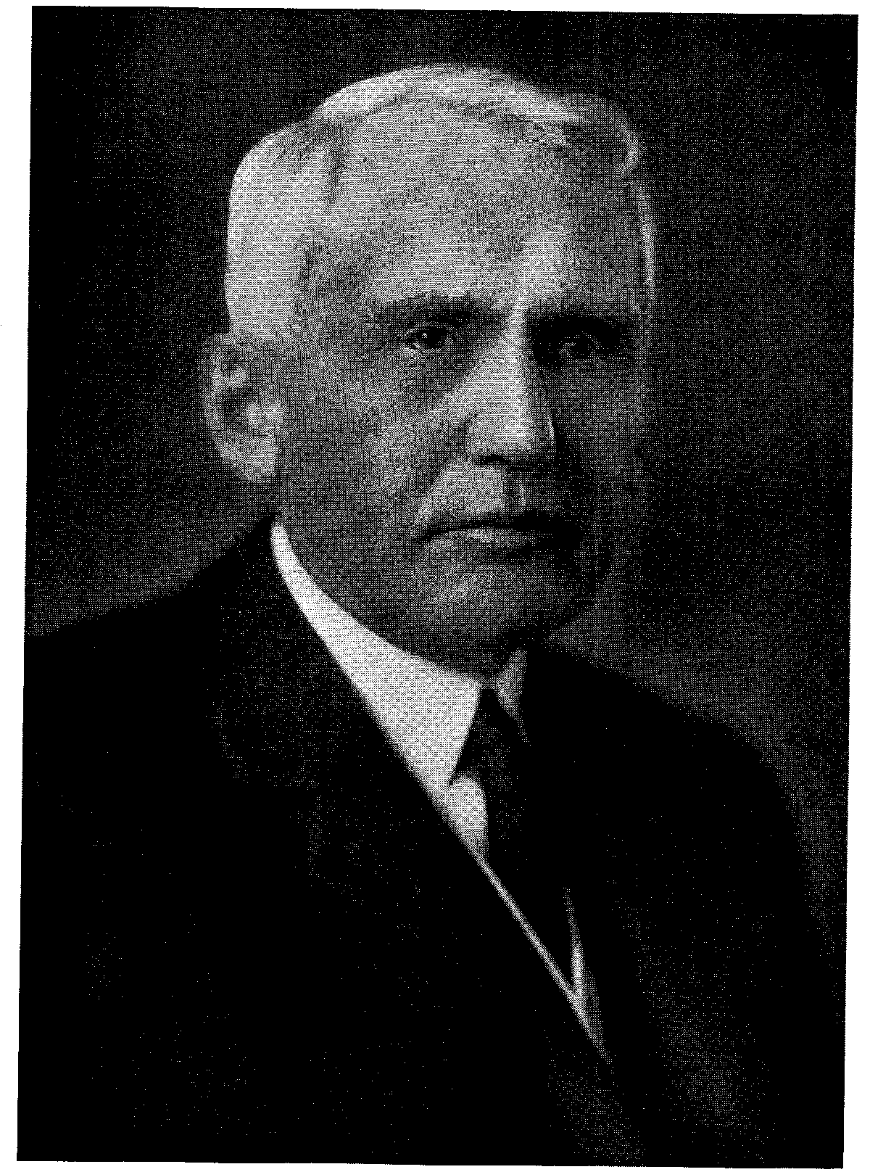
FRANK BILLINGS KELLOGG
(1856 – 1937)
In the American Bar Association, Kellogg has been active, efficient and generous. He brought about the ceremonial visit of Lord Haldane to the joint Montreal meeting by a personal trip to England and it is an open secret that Kellogg himself financed the expedition for the Association. His capacity as a lawyer and his lawyer’s outlook range through the whole course of his life. Inexhaustible diligence and unwavering attention to the job at hand are the qualities that most impress a reviewer. The great pyramid of fame he built was laid from little blocks.

________________

Related Article: Roger G. Kennedy, “Frank Billings Kellogg” (MLHP, 2008-2011)

♦◄♦►♦

Posted MLHP: September 2008;
reformatted August 13, 2012.

In his autobiography, Haldane described his visit and his speech: Before going further with this chapter I ought to refer to an event which occurred while I was Chancellor, and which was the first of the kind in the history of the office. In August 1913 I paid a brief visit to the United States and to Canada. President Wilson and some of the leading statesmen and the United States on the one hand, and the Governor-General of Canada, the Duke of Connaught, and the Prime Minister, Mr. Borden, had joined in an invitation to me to take the course, novel for a British Custodian of the Great Seal, who has to remain in our country, of crossing the Atlantic and delivering an address to the American and Canadian Bar Associations and the public generally. The place was to be Montreal, and the occasion the impending centenary of the Treaty of Ghent. The two Bar Associations had agreed to meet there to commemorate the occasion. Mr. Kellogg, then President of the American Bar Association, and afterwards to be Ambassador here and Secretary of State at Washington, came personally to London and pressed on me the invitation. The Cabinet here thought that I should manage to go, but that I should restrict my visit to a week-end, and so avoid having to avail myself of formal invitations to visit Washington and Ottawa, which would probably have entailed the spending of much time which could not well be spared in travelling to other places as the alternative to disappointment. This so-called “lightning visit” took place, and the details were fully published in the newspapers of the day. On the preparation of the address delivered I spent time. Its subject was the material for conciliation between the three nations. The theme was that we were reaching a stage in which we might well hope that the Ententes between the nations I was addressing, and on the other hand between them and France and Russia, as well as Germany and Austria, might be so directed as to lend themselves to a still further-reaching Entente. In the spirit of this larger understanding we might hope for and find the best in other nations, and so develop a world-wide “Sittlichkeit” or sense of good form, as distinguished from mere law or pure ethics, which should provide a firmer basis for International Law and reverence for International Obligations and establish respect for the rights and duties of foreign nations. Richard Burton Haldane, An Autobiography 276-278 (New York: Doubleday, Doran & Co., Inc., 1929). Haldane’s speech was delivered about one year before the outbreak of World War I.
Henry L. Stimson & McGeorge Bundy, On Active Service in Peace and War 192-93 (New York: Harper & Bros., 1947).
Some historians are still ambivalent about Kellogg. See e.g., Barbara Stuhler, Ten Men of Minnesota and American Foreign Policy, 1898-1968 99-122 (St. Paul: Minnesota Historical Society Press, 1973). The debit side of Kellogg’s “balance sheet” has grown in recent years. See, e.g., Roger G. Kennedy, “Frank Billings Kellogg”, in Men on the Moving Frontier 133-151 (American West Publishing Co., 1969); it is posted separately on the MLHP.
New York Times, April 25, 1971, at 73. (MLHP: Rogers’ grandchildren point to an error in the Times’ obituary: Rogers was the president of the Denver Club, not the City Club; and he was President of the University and Cactus Clubs in Denver as well.)

